Data Modification Problem1
- Modification Statement
INSERT INTO Facility (FacNo,FacName)
VALUES ('F104','Swimming Pool');
- Before (4 rows)
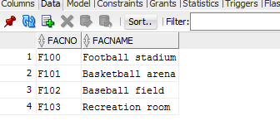
- Inserted
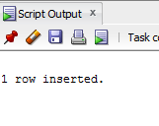
- After(5 rows)
